Zeta Gamma Gamma Chapter
of
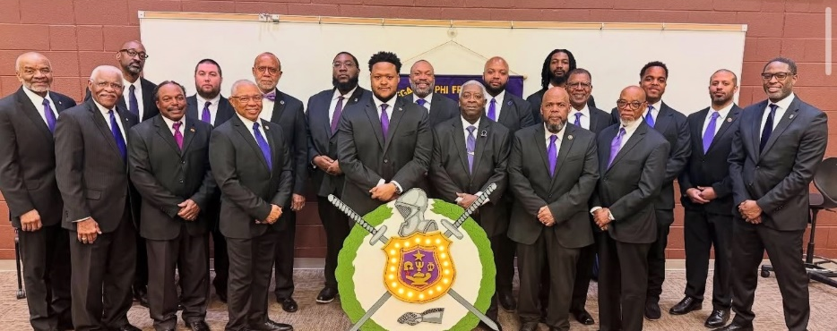
Omega Psi Phi 2025 Highlights

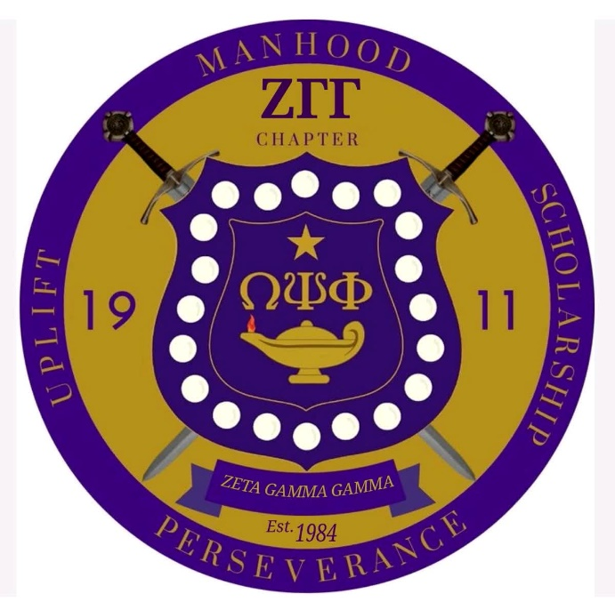

Introduction and Presentation
The Zeta Gamma Gamma Graduate Chapter proudly submits this Yearbook for consideration as Graduate Chapter of the Year 2025. Throughout the 2025 calendar year, our chapter has continued to embody the cardinal principles of Manhood, Scholarship, Perseverance, and Uplift, serving as a steadfast beacon of leadership, service, and community engagement within the East Tennessee region.
This submission highlights the chapter’s achievements, initiatives, and unwavering dedication to the mission of Omega Psi Phi Fraternity, Inc. Each section of this document has been prepared in strict accordance with the guidelines established by the International Headquarters, ensuring clarity, completeness, and alignment with the standards of excellence expected of a Graduate Chapter of the Year contender.

Table of Contents
Introduction and Presentation 2
Table of Contents 2
Achievement Week 2025 3
Scholarship 4
Leadership Conference Delegates 5
Memorial Service 6
Social Action 7
Talent Hunt 10
Reclamation/Retention 11
College Endowment Fund 11
NAACP Life Member (Gap) 12
International Health Initiatives 12
Other Local Community-Based Activities 13
Signature Page 14

Achievement Week 2025
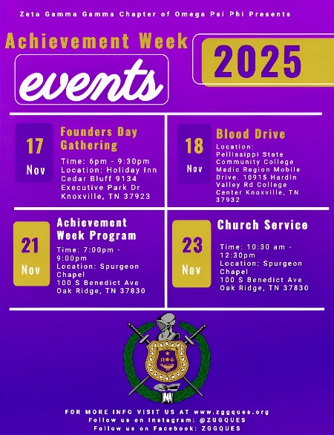
Zeta Gamma Gamma Chapter
2025 Observance and Community Impact
The Zeta Gamma Gamma (ZGG) Chapter of Omega Psi Phi Fraternity, Inc. launched its 2025 Achievement Week with a meaningful fellowship gathering that united the Brothers of both ZGG and the Iota Alpha (IA) Chapter. This joint event strengthened fraternal bonds, promoted unity, and set a positive tone for a week dedicated to service, recognition, and uplift.
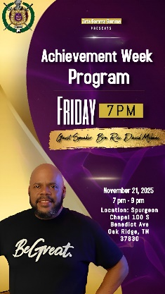
As part of its commitment to community health and civic engagement, the chapter hosted a blood drive on November 18th in collaboration with Medic Mobile and Pellissippi State Community College. This initiative provided an opportunity for students, community members, and fraternity brothers to contribute to lifesaving efforts across the region.
On November 23rd, the Brothers attended a special church service at Spurgeon Chapel Baptist Church as part of the chapter’s Achievement Week observance. This worship experience offered a moment of spiritual reflection, gratitude, and unity, reinforcing the fraternity’s dedication to faith, fellowship, and service within the Oak Ridge community.
Key Note Speaker Rev. Bro. David Mebane for ZGG 2025 Achievement Week
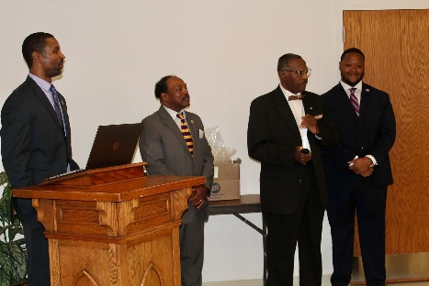
A highlight of the week was the recognition of Citizen of the Year Roy Guthrie, honored for his outstanding service and unwavering dedication to the City of Oak Ridge. His contributions exemplify the values of leadership, commitment, and community uplift that Achievement Week seeks to celebrate.
Bro. Justin Rosser, Rev. Bro. Gary Atwater, Bro. Eugene Miller, and Bro. Richard Riley commencing the award ceremony for Achievement Week November 21, 2025
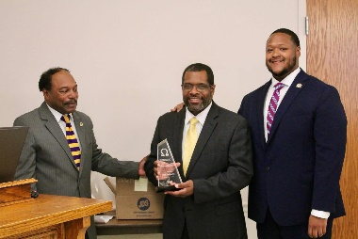
Throughout the observance, ZGG honored local leaders, recognized student scholars, and reinforced Omega Psi Phi’s mission of uplift. The chapter’s efforts demonstrated a continued dedication to scholarship, service, and the advancement of the communities it proudly serves.
2025 Zeta Gamma Gamma Chapter Citizen of the Year Roy Guthrie, Achievement Week Ceremony November 21, 2025

Scholarship
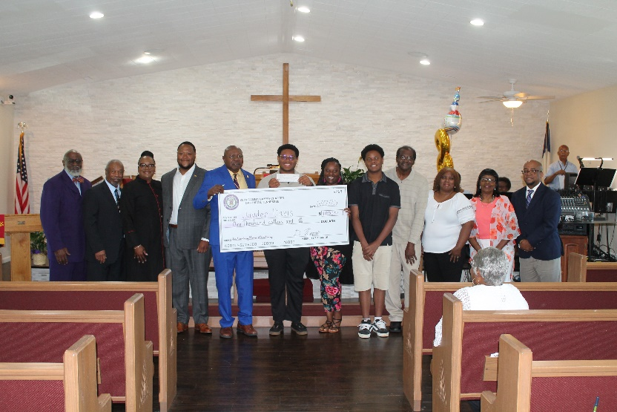
On June 22, 2005, the Zeta Gamma Gamma (ZGG) Chapter of Omega Psi Phi Fraternity, Inc. proudly awarded the Josh Allen Young Memorial Scholarship which is an $1,000 academic scholarship, to Jayden Davis, an outstanding graduating senior at Oak Ridge High School. This scholarship reflects the chapter’s ongoing commitment to supporting academic excellence and uplifting promising youth within the local community.
Josh Allen Scholarship Award June, 22 2025
Mr. Davis was selected based on his strong academic performance, leadership qualities, and demonstrated dedication to furthering his education. His application exemplified the principles of Scholarship and Perseverance, aligning with the fraternity’s mission to encourage and reward high-achieving students who show potential for future success.
The presentation of the scholarship served as a meaningful moment for both the recipient and the chapter, reinforcing Zeta Gamma Gamma’s role as a positive force in the Oak Ridge community. By investing in students like Jayden Davis, the chapter continues to honor its legacy of service and its commitment to empowering the next generation of leaders.

Leadership Conference Delegates
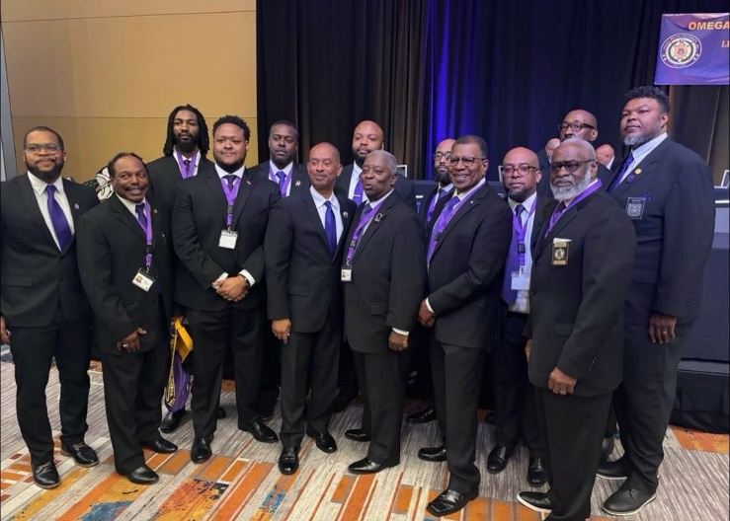
77th Legendary 5th District Meeting – Memphis, Tennessee
ZGG Brother and Delegates at the 2025 District Meeting
The 77th Legendary 5th District Meeting was successfully held in Memphis, Tennessee, bringing together brothers from across the district for a meaningful gathering focused on leadership, fellowship, and service. Memphis, a city rich in history and cultural significance, provided an appropriate backdrop for a meeting that honored the legacy of the district while setting a clear vision for the future.
Throughout the meeting, brothers engaged in structured sessions that addressed district business, strategic initiatives, and chapter operations. Key discussions emphasized strengthening chapter effectiveness, expanding community impact, and reinforcing the core principles and values that define the organization. Workshops and reports highlighted best practices, shared successes, and provided guidance to support continued growth and excellence at the chapter level.
In addition to business sessions, the meeting fostered fellowship and brotherhood through formal and informal engagements. These moments allowed brothers to reconnect, build new relationships, and reaffirm their collective commitment to service, leadership, and uplift within their respective communities. Recognition of outstanding service and dedication further underscored the district’s appreciation for brothers who exemplify excellence and commitment.
Overall, the 77th Legendary 5th District Meeting in Memphis was a resounding success. It reinforced unity across the district, honored the organization’s proud history, and energized members to return to their chapters with renewed purpose, clarity, and motivation to continue impactful work in their communities

Memorial Service
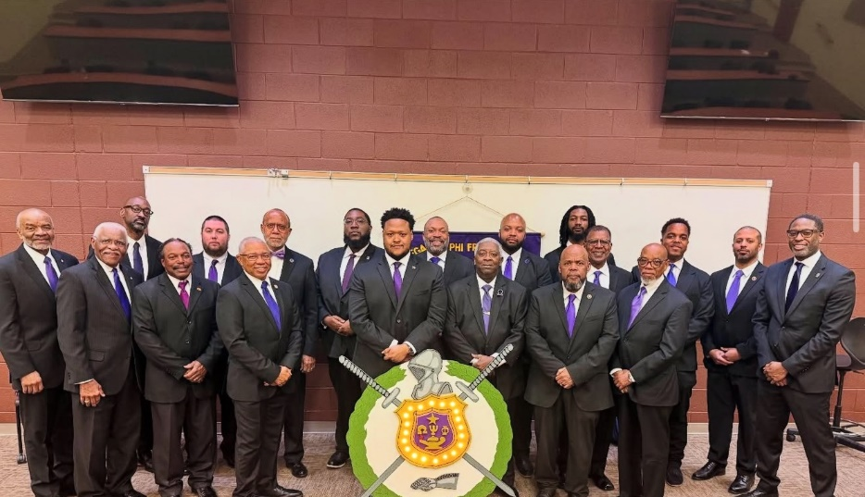
The brothers of the Zeta Gamma Gamma (ZGG) Chapter of Omega Psi Phi Fraternity, Inc. gathered on March 21, 2025, to conduct our annual Memorial Service honoring the noble brothers who have transitioned to the Omega Chapter. This solemn observance remains one of the most sacred traditions within our fraternity, providing an opportunity to reflect on the lives, legacies, and lasting impact of those who have served with distinction.
ZGG Memorial Service March 21, 2025
The ceremony was carried out with dignity, reverence, and adherence to the ritualistic standards of Omega Psi Phi. Brothers assembled in formal attire and participated in the structured program, which included scripture, reflections, the reading of names, and moments of silence dedicated to each departed brother. The atmosphere was one of unity and deep respect, as members collectively acknowledged the contributions and sacrifices made by our fallen brothers.
This year’s service reinforced the chapter’s commitment to preserving the memory of those who paved the way for our continued excellence. It also served as a reminder of the enduring bond of brotherhood that extends beyond this life into Omega Chapter.
The Memorial Service concluded with closing remarks and a reaffirmation of our duty to uphold the principles of Manhood, Scholarship, Perseverance, and Uplift in honor of those who came before us. The brothers of Zeta Gamma Gamma remain steadfast in ensuring that the legacy of our transitioned brothers is never forgotten.

Social Action
Zeta Gamma Gamma Chapter
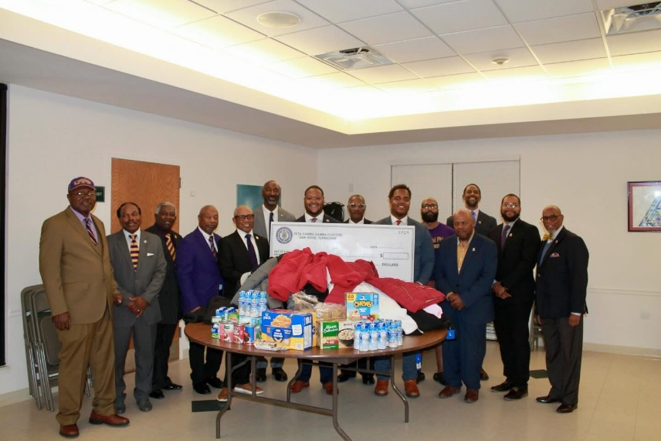
Coat & Food Drive Collaboration with Oak Valley Baptist Church
The Brothers of the Zeta Gamma Gamma (ZGG) Chapter of Omega Psi Phi Fraternity, Inc., in partnership with Oak Valley Baptist Church, successfully organized and executed a community-focused coat and food drive. This collaborative initiative was designed to provide essential support to individuals and families in need as the winter season approaches.
Zeta Gamma Gamma and Oak Valley Baptist Church Coats and Good Drive November 15, 2025
Through the combined efforts of chapter members, church partners, and generous community donors, the drive yielded meaningful results. A total of $691 in monetary contributions was collected, along with 68 coats and 40 pounds of food designated for distribution to vulnerable households. These contributions reflect the shared commitment of ZGG and Oak Valley Baptist Church to uplift the community and address critical needs during colder months.
The chapter expresses sincere gratitude to all who contributed to the success of this initiative. The donations received will directly benefit local residents, helping ensure that more families remain warm, nourished, and supported throughout the upcoming winter season. This effort stands as a testament to the power of collaboration and the enduring impact of service rooted in the principles of Omega Psi Phi Fraternity, Inc.
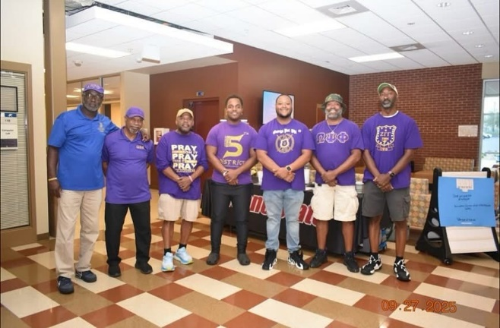
Zeta Gamma Gamma Chapter
Support of the ORAU 35th HBCU College Fair & Expo
October 27, 2025
On October 27, 2025, the Brothers of the Zeta Gamma Gamma (ZGG) Chapter of Omega Psi Phi Fraternity, Inc. proudly supported the Oak Ridge Chapter of Delta Sigma Theta Sorority, Inc. during the Oak Ridge Associated Universities (ORAU) 35th Historically Black College and University (HBCU) College Fair and Expo. This annual event serves as a vital platform for connecting local students with representatives from HBCUs across the nation, promoting access to higher education and expanding awareness of academic opportunities.
ZGG 35th HBCU College Fair and Expo October 27, 2025
ZGG’s presence at the event reinforced the chapter’s commitment to uplifting youth and strengthening partnerships with fellow Divine Nine organizations. Brothers assisted with event operations, engaged with students and families, and helped ensure a welcoming and informative environment for all attendees. Their participation contributed to the overall success of the expo and demonstrated the fraternity’s ongoing dedication to scholarship, mentorship, and community collaboration.
By supporting this long-standing educational initiative, the Zeta Gamma Gamma Chapter continues to advance the principles of Omega Psi Phi Fraternity, Inc., while fostering meaningful connections that encourage academic achievement and broaden pathways for future generations.

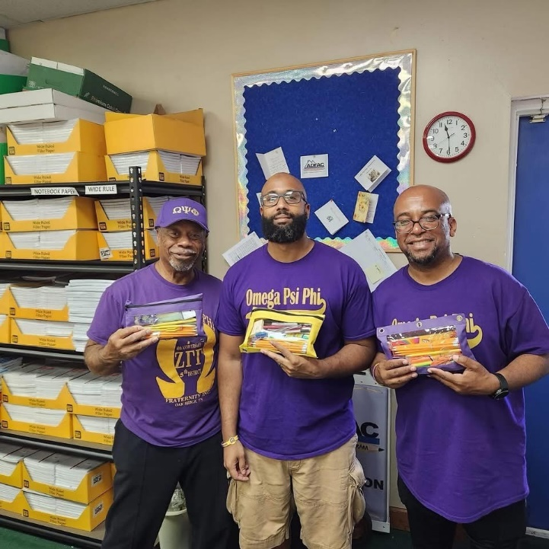
Zeta Gamma Gamma Chapter
Participation in ADFAC School Supplies Drive
ADFAC School Supplies Drive April 23, 2025
The Brothers of the Zeta Gamma Gamma (ZGG) Chapter of Omega Psi Phi Fraternity, Inc. proudly supported the annual school supplies drive organized by Aid to Distressed Families of Appalachian Counties (ADFAC). This initiative plays a vital role in equipping students across East Tennessee with the tools they need to begin the academic year prepared and confident.
As active participants in the drive, ZGG assisted in the distribution of essential school supplies to 6,000 eligible students enrolled in 50 partner schools across Anderson, Campbell, Morgan, and Roane counties. These efforts directly contributed to ensuring that each student received a fresh set of materials—an important step in promoting academic readiness and reducing barriers to educational success.
The chapter’s involvement reflects its ongoing commitment to uplifting youth and strengthening community partnerships. By supporting ADFAC’s mission, the Brothers of Zeta Gamma Gamma helped create a positive start to the school year for thousands of students, reinforcing the fraternity’s dedication to service and the principle of Uplift.

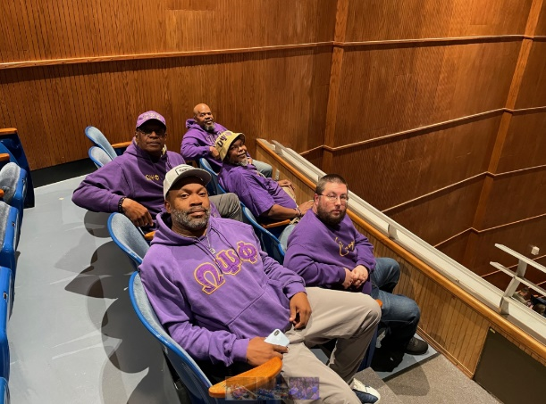
Zeta Gamma Gamma’s collaboration with Justice Knox
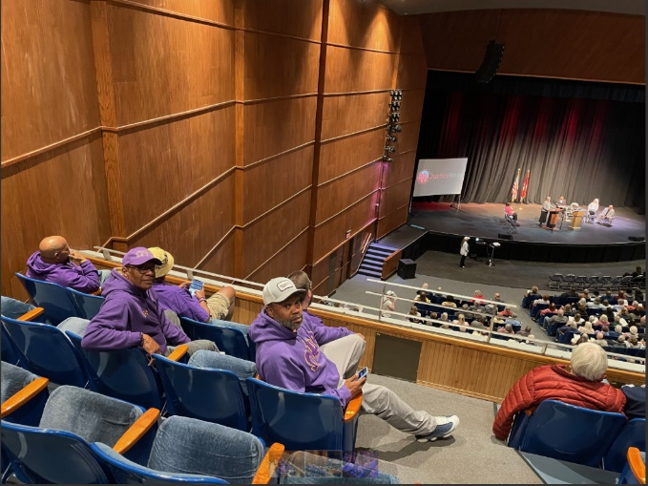
On April 8, 2025, the Zeta Gamma Gamma Chapter demonstrated significant leadership and civic engagement through its strong support of Justice Knox, participating in a major citywide rally attended by more than 1,000 residents from across Knoxville and Knox County. During this event, ZGG joined a unified coalition of community members committed to advancing meaningful, long-term solutions to the issues most affecting local quality of life.
ZGG Collaboration with Justice Knox April 8, 2025
Standing together as one voice, we worked alongside faith leaders, neighborhood advocates, and partner organizations to identify and confront the root causes of injustice in our community. Our collective advocacy elevated critical concerns—including homelessness, the shortage of affordable housing, and inadequate public transportation in economically disadvantaged areas.
As a direct result of this unified effort, City and County officials responded with substantial commitments. These included $5 million annually for 10 years dedicated to affordable housing development, increased funding to expand public transportation services, and pledged support for housing initiatives benefiting homeless veterans.
ZGG’s involvement in this movement reflects the chapter’s ongoing dedication to social justice, community empowerment, and collaborative action that produces measurable, lasting change.
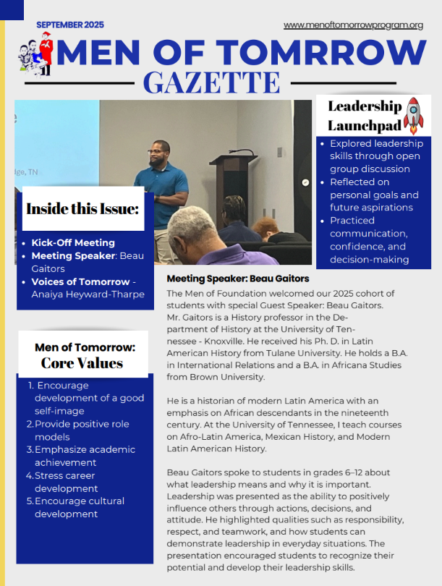
Bro. Beau Gaitors support ZGG Men of Tomorrow Program September 2025

Talent Hunt

The Zeta Gamma Gamma Chapter of Omega Psi Phi Fraternity, Inc. held its annual Talent Hunt on March 1, 2025, at Oak Valley Baptist Church. The competition showcased remarkable youth talent, with Shermija Whitehead earning first place and a $500 award, and Sidney Jean-Philippe securing second place and a $250 award. Both participants delivered powerful and inspiring praise dance performances that moved the audience and demonstrated exceptional artistic expression.

Reclamation/Retention
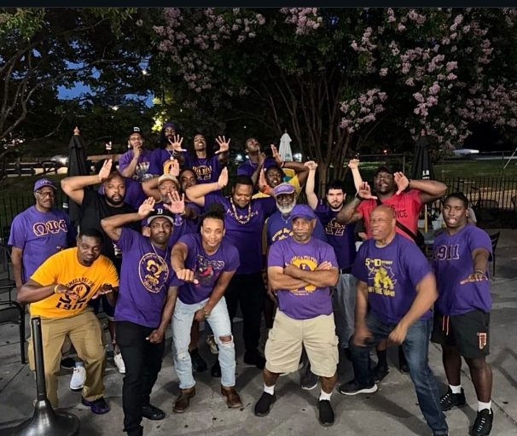
Zeta Gamma Gamma Chapter
June 9, 2025
Reclamation Event June 9, 2025
The Brothers of the Zeta Gamma Gamma (ZGG) Chapter of Omega Psi Phi Fraternity, Inc. hosted a reclamation and retention event on June 9th at The Hill Bar and Grill, located near the University of Tennessee at Knoxville. This gathering served as an opportunity to strengthen fraternal bonds, reconnect with inactive brothers, and reinforce the chapter’s commitment to sustained brotherhood.
The event provided a welcoming environment where brothers could engage in meaningful conversation, share updates on chapter initiatives, and encourage continued involvement in fraternity activities. By creating space for fellowship and reconnection, ZGG advanced its ongoing efforts to retain active members and reclaim brothers who have been away from chapter engagement.
This initiative reflects the chapter’s dedication to fostering unity, promoting brotherly accountability, and ensuring that all members feel valued and connected to the mission and principles of Omega Psi Phi Fraternity, Inc.

College Endowment Fund
Zeta Gamma Gamma Chapter
College Endowment Fund Contribution – 2025
In 2025, the Brothers of the Zeta Gamma Gamma Chapter of Omega Psi Phi Fraternity, Inc. reaffirmed their commitment to advancing educational opportunity by contributing $400 to the College Endowment Fund. This investment reflects the chapter’s enduring dedication to supporting the academic aspirations of youth throughout the community.
The College Endowment Fund serves as a vital resource for students seeking to pursue higher education, providing financial assistance that helps reduce barriers and expand access to collegiate pathways. Zeta Gamma Gamma’s contribution strengthens this mission by ensuring that deserving young scholars have the support they need to pursue their goals with confidence.
This act of service aligns directly with the fraternity’s cardinal principles—particularly Scholarship and Uplift—demonstrating the chapter’s belief that empowering the next generation through education is one of the most meaningful ways to build stronger communities. Through this contribution, the Brothers of Zeta Gamma Gamma continue to champion academic excellence and invest in the future leaders of tomorrow.

NAACP Life Member (Gap)
- Chapter proudly maintains NAACP Life Membership.
- Certificate attached.

International Health Initiatives

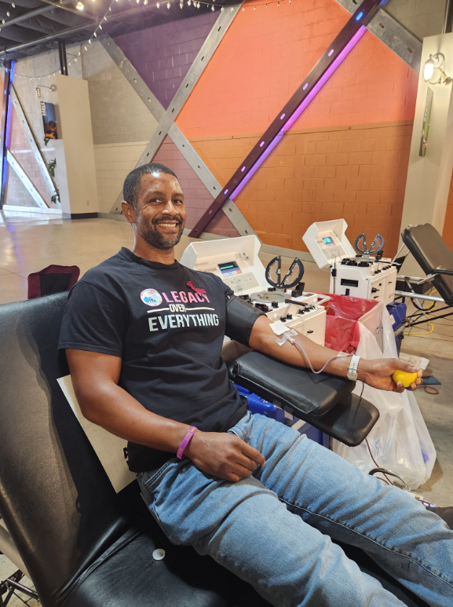
On November 18, 2025, the Zeta Gamma Gamma Chapter of Omega Psi Phi Fraternity, Inc. proudly supported a regional blood drive in partnership with Medic Regional Blood Center. The event, hosted at Pellissippi State Community College, was a tremendous success.
As shown in the attached photo, one of our Brothers even took the initiative to donate more than a month in advance by participating in an American Red Cross drive, helping to bolster the supply of life-saving blood ahead of our scheduled event. His early contribution, along with the generosity of all who donated, helped ensure a steady and reliable blood supply for our region.
Thank you to everyone who came out to give and support this vital cause. It was an honor to serve our community alongside Medic Regional Blood Center and Pellissippi State Community College.
Bro. Justin Rosser donating blood on November 18, 2025 for Omega Achievement Week

Other Local Community-Based Activities
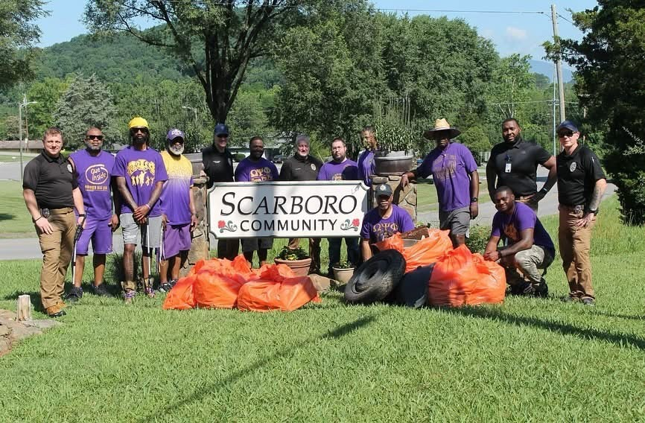
Zeta Gamma Gamma Chapter
Scarboro Community Cleanup Initiative
ZGG and the Oak Ridge Police Department Scarboro Community Cleanup July 11, 2025
The Brothers of the Zeta Gamma Gamma (ZGG) Chapter of Omega Psi Phi Fraternity, Inc. partnered with the Oak Ridge Police Department to conduct a community cleanup in the historic Scarboro neighborhood. This collaborative effort reflects the chapter’s ongoing commitment to service, civic responsibility, and the preservation of community pride.
This initiative holds special significance for the chapter, as it continues the legacy of Brother Lieutenant Marvell Moore, who originally established the Scarboro Community Cleanup Program in partnership with Omega Psi Phi and the Oak Ridge Police Department. Brother Moore’s vision centered on strengthening relationships between residents, law enforcement, and community organizations while improving the overall environment and quality of life within Scarboro.
By participating in this cleanup effort, the Brothers of ZGG honored Brother Moore’s enduring impact and reaffirmed their dedication to the principle of Uplift. Working alongside officers and community volunteers, the chapter helped remove litter, enhance public spaces, and promote a cleaner, safer neighborhood for local families.
The Zeta Gamma Gamma Chapter remains committed to sustaining this tradition of service and ensuring that Brother Moore’s legacy continues to inspire meaningful community engagement for years to come.
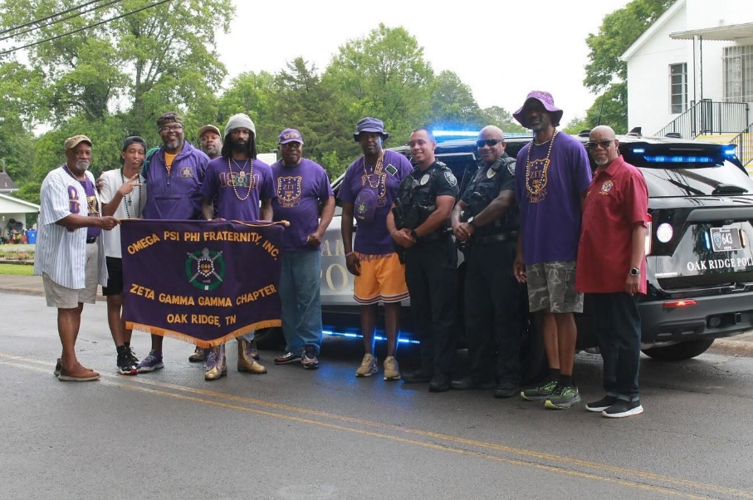
Participation of Zeta Gamma Gamma in the Scarboro Community Unity Parade
ZGG at the Scarboro Community Unity Day parade June 9, 2025
The brothers of Zeta Gamma Gamma proudly participated in the Scarboro Community Unity Parade, a signature event held as part of the Scarboro Community Alumni Reunion. This parade serves as a powerful celebration of legacy, resilience, and unity, honoring the deep and rich history of the Scarboro community. The event recognizes the enduring contributions of the Black community in Oak Ridge—individuals and families who helped build, sustain, and strengthen the community through generations despite significant challenges.
Zeta Gamma Gamma’s participation reflected the chapter’s continued commitment to community engagement, historical awareness, and service. By marching alongside alumni, residents, and community leaders, the brothers demonstrated solidarity with Scarboro’s mission to preserve its cultural heritage and uplift future generations. Their presence reinforced the importance of remembering the past while actively supporting the community’s ongoing efforts to celebrate identity, foster unity, and inspire pride in Scarboro’s remarkable history.

Signature Page

Submitted respectfully,

Zeta Gamma Gamma Chapter
Omega Psi Phi Fraternity, Inc.
2025 Calendar Year

